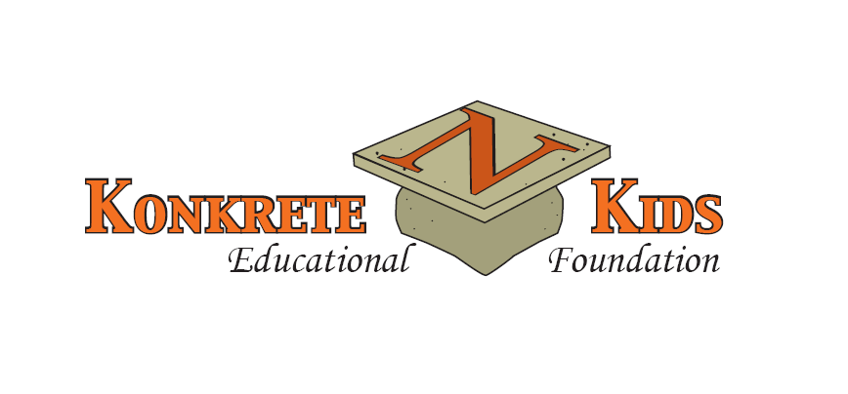

DISTINGUISHED ALUMNI AWARD
Nomination Information

PURPOSE STATEMENT
The Distinguished Alumni Award, sponsored by the Northampton Area Konkrete Kids Educational
Foundation, will make current Northampton Area School District students, graduates, and the community
aware that our school district produces outstanding graduates and role models who have demonstrated
leadership and excellence in their professional and personal lives.

NOMINATION CRITERIA
A candidate for the Distinguished Alumni Award must have graduated from Northampton Area
High School at least 15 years prior to his/her nomination for the Award. A nominee does not need to be
a current resident of the Northampton Area School District, but the nominee should reflect some of the
following criteria:

- a person who has achieved outstanding success in his/her chosen field or profession
- a person who has performed substantial community service or volunteer work
- a person who has made a positive impact on others
- a person who has received special recognition or awards
*****Posthumous nominations will be accepted.

SELECTION
All nominations submitted by the Friday, March 27, 2026, deadline will be carefully reviewed by the
Distinguished Alumni Award Committee, and the selected DAA honoree(s) will be notified in April 2026.

AWARDS PROGRAM
The selected honoree(s) for the Distinguished Alumni Award will have a permanent plaque placed on
the Distinguished Alumni Wall of Honor located in the main lobby of Northampton Area High School,
and the Award recipient(s) will be publicly honored at the Distinguished Alumni Award CELEBRATION on
September 27, 2026, at Woodstone Country Club and Lodge, Danielsville, PA.

Nomination Forms may be submitted as soon as possible, but no later than the
Friday, March 27 deadline.
____________________________________________________________________________________________________________________________
Mail or Email DISTINGUISHED ALUMNI AWARD Nomination Form(s) by March 27, 2026 to:

Northampton Area Konkrete Kids Educational Foundation
Attn. Distinguished Alumni Award Committee
PO Box 816, Cherryville, PA 18035

Visit the Northampton Area Konkrete Kids Educational Foundation (www.konkretefoundation.org) for additional information
or call 610-767-7824.

