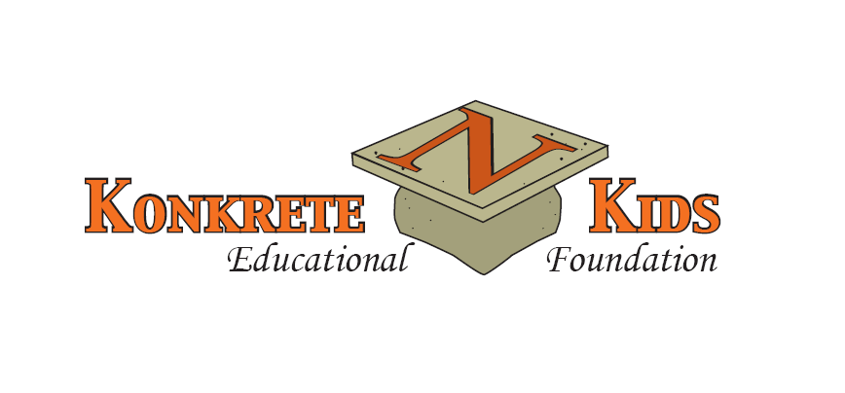

DISTINGUISHED ALUMNI AWARD
NOMINATION FORM
1. Please print legibly.
2. Please provide as much detailed information as possible.
3. A completed Nomination Form may be submitted as soon
as possible, but no later than the deadline date of
Friday, March 27, 2026.

I. NOMINATOR Information (Required)
A. Date: _________________________
B. Name: (Mr., Mrs., MS): ________________________________________________________
C. Address: _____________________________________________________________________
(city) (state) (zip)
D. Phone: __________________________ E-Mail: _____________________________________
E. Relationship to Nominee: _______________________________________________________ F. How did you hear about the Distinguished Alumni Award? (Options: Newspaper, Email, Friend/Family, Past Honoree, etc.)_______________________________________

II. NOMINEE Information
A. Name of Nominee: (Mr., Mrs., MS): _______________________________________________
Please include maiden name, when applicable.
B. Northampton Area High School Class of _________
C. Address ______________________________________________________________________
(city) (state) (zip)
D. Phone___________________________E-Mail_______________________________________
*** (If Nominee is deceased, please provide/attach contact information (name, address,
phone, E-Mail) for a relative or close friend who can be contacted by the Committee.)

***Please provide as much specific and detailed information as possible for each of the following categories,
and, if necessary, additional information to support this person’s nomination may be attached to this Nomination Form. When possible, please avoid using abbreviations.

I. Nominee’s education history beyond graduation from Northampton Area High School:
(Include degree(s), technical certificate(s), military service, etc.)
_______________________________________________________________________________________

_______________________________________________________________________________________

_______________________________________________________________________________________

II. Nominee’s profession/chosen field/title:

__________________________________________________________________________

_______________________________________________________________________________________

III. Nominee’s employment history:
(A resume, vitae, and/or dossier may be include/attached in order to provide details.)

______________________________________________________________________________________

______________________________________________________________________________________

______________________________________________________________________________________

IV. Nominee’s accomplishments in his/her profession/chosen field:

______________________________________________________________________________________

______________________________________________________________________________________

______________________________________________________________________________________

V. Nominee’s volunteer work and/or community service:
Note: This may be in location(s) outside/beyond the NASD community.

_____________________________________________________________________________________

_____________________________________________________________________________________

_____________________________________________________________________________________

VI. Nominee’s positive impact on or contribution to others:

____________________________________________________________________________________

____________________________________________________________________________________

____________________________________________________________________________________

VII. Special recognition(s) or award(s) given to Nominee:

____________________________________________________________________________________

____________________________________________________________________________________

____________________________________________________________________________________

Please remember: Additional information to support this person’s nomination may be attached to this Nomination Form.

Please submit the completed Nomination Form to: Distinguished Alumni Award Committee, Box 816,
Cherryville, PA 18035, no later than March 27, 2026.

If you have any questions, please contact 610-767-7824. Thank you for your support of this Nomination
Process for the Northampton Area Konkrete Kids Educational Foundation’s 2026 Distinguished Alumni
Award project. All monies raised through this fundraiser are used to enhance the educational program of NASD students.

